Assignment 2:  
Client Install + IDM Users and Groups

*Kyle Walker*

*OSYS3030*

*10/01/2024*

Table of Contents

Task 1: IPA Server Update 2

Question 1: 4

Question 2: 4

Documentation: 5

# Task 1: IPA Server Update

*Firewall Report:*

public (active)

target: default

icmp-block-inversion: no

interfaces: ens33

sources:

services: cockpit dhcpv6-client dns freeipa-ldap freeipa-ldaps http https kerberos kpasswd ntp ssh

ports: 53/tcp 80/tcp 88/tcp 389/tcp 443/tcp 464/tcp 88/udp 464/udp 123/udp

protocols:

forward: yes

masquerade: no

forward-ports:

source-ports:

icmp-blocks:

rich rules:

*Commands Used For Report:*

“sudo firewall-cmd –permanent –add-port=(PORT #)/(TCP/UDP)”

“sudo firewall-cmd –list-all > ~/Documents/firewall_report.txt”

*Hostname and DNS Settings:*

*“nmcli” Results:*

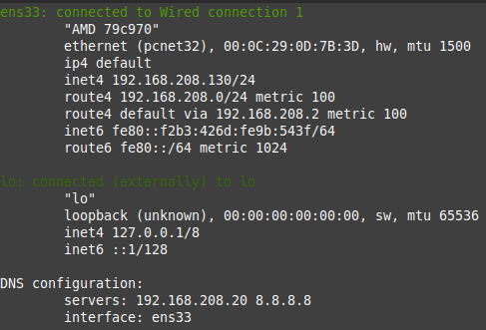

## Question 1:

**What is LDAP, how does it work and how do we use it in a Windows/Linux hybrid network?**

LDAP (Lightweight Directory Access Protocol) is like a Linux version of Active Directory. It organizes data for users on a domain in a similar way, with trees, branches and leaves. Instead of OU’s that we’re used to in AD, it instead uses DN’s (Distinguished Names).

LDAP seems to work seamlessly with AD as well, as it can authenticate users on both Windows and Linux systems at the same time as AD already uses LDAP for some of its protocols.

*Selected Name Services:*

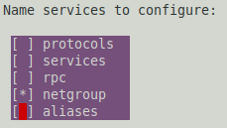

(small window, no other services selected)

## Question 2:

**What is a umask, and what does the particular umask used mean?**

A umask (User Mask) is a setting to determine permissions on new files that users create in Linux systems. Umask values usually consist of 3 to 4 digits with each digit meaning a different permission, similar to NTFS permissions in Windows. Linux operates a little differently when it comes to permissions and users however, as Linux only sees Users, Groups and Others.

Umask=0077 means that there are no restrictions for the owner (full control), but no permissions for the group and no permissions for others. So basically, the owner of the home directory folder will have full permissions, but nobody else will.

# Documentation:

*Client Snapshots:*

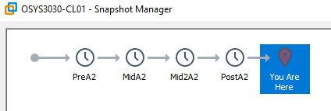

*Server Snapshots:*

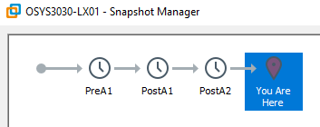

*Gold Copies:*

